**PROGRAM-6 TURTLE-GRAPHICS**

1. **Write a python program to print forward arrow directions?**

import turtle

t = turtle.Turtle()

t.forward(100)

turtle.mainloop()

**sample output:**

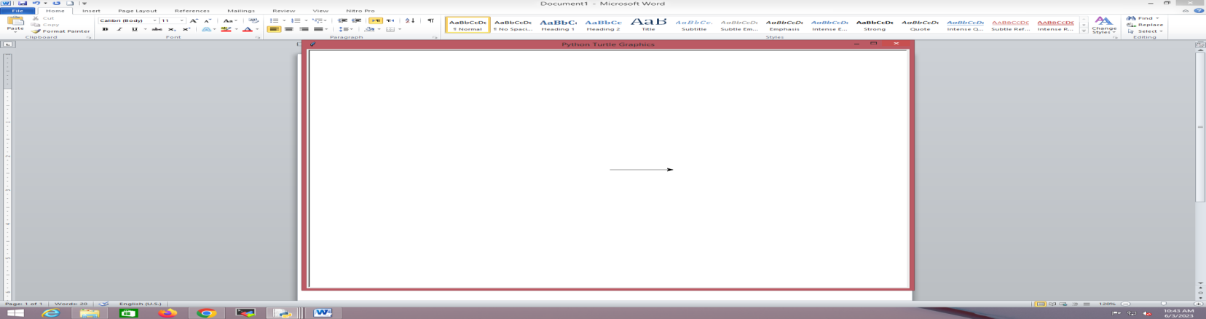

1. **write a python program using tutrtle graphics to print circle ?**

import turtle

t = turtle.Turtle()

t.circle(50)

turtle.mainloop()

**sample output:**

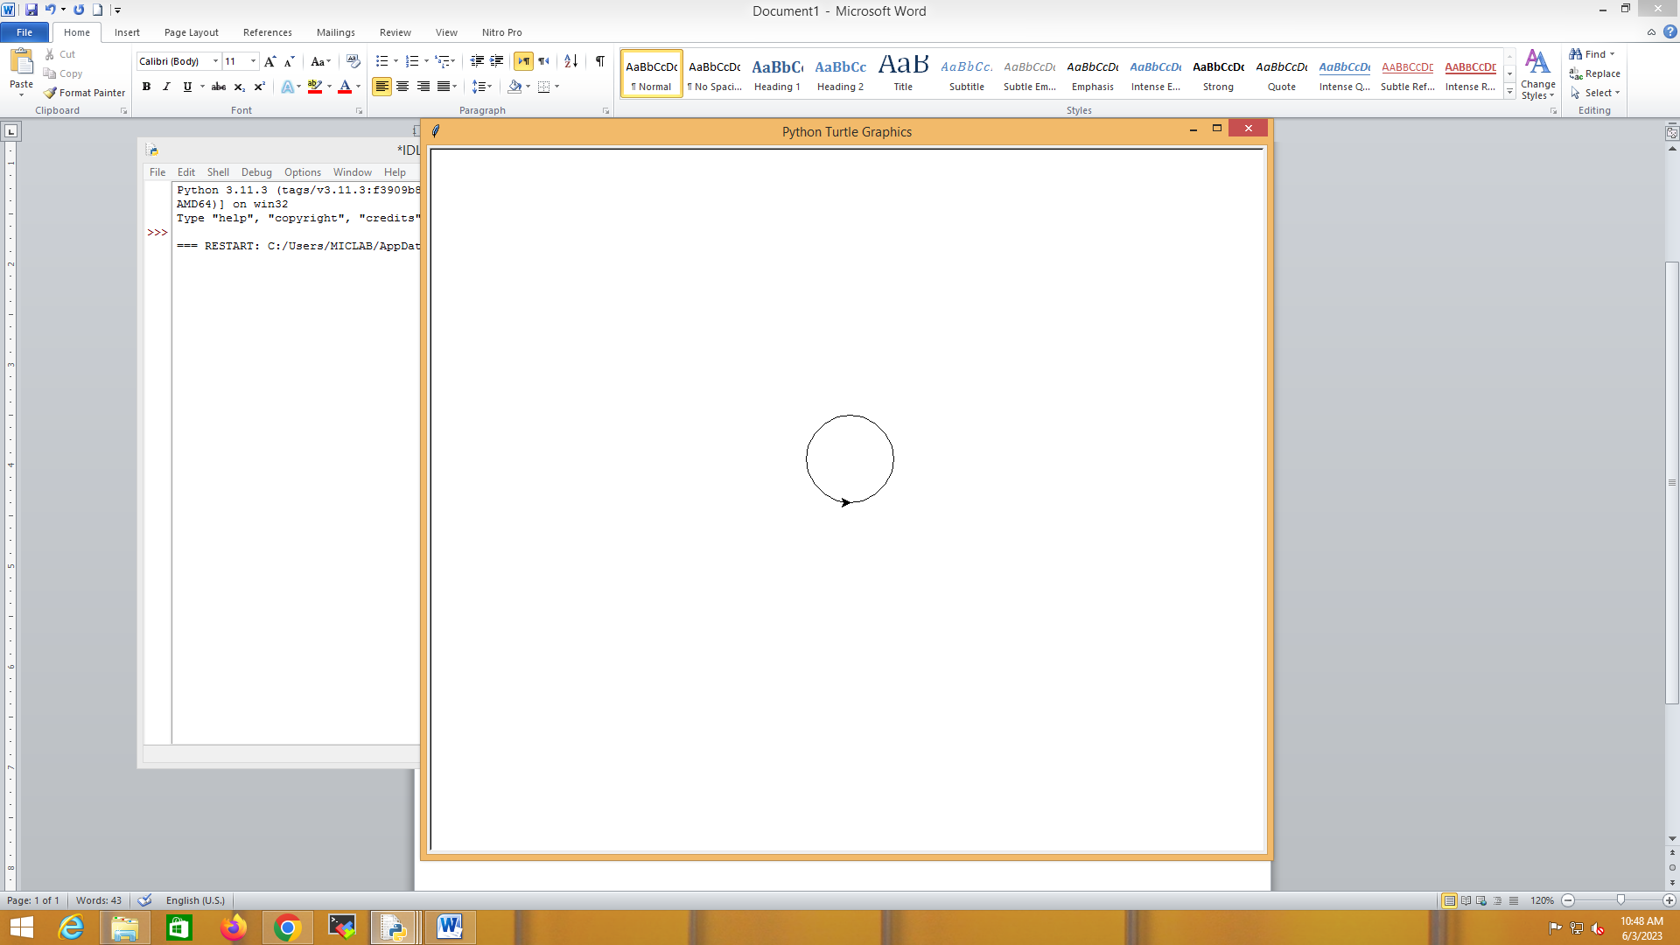

1. **Write a program to print background colour using turtle grapics?**

import turtle

t = turtle.Turtle()

turtle.bgcolor("red")

turtle.mainloop()

**Sample and output:**

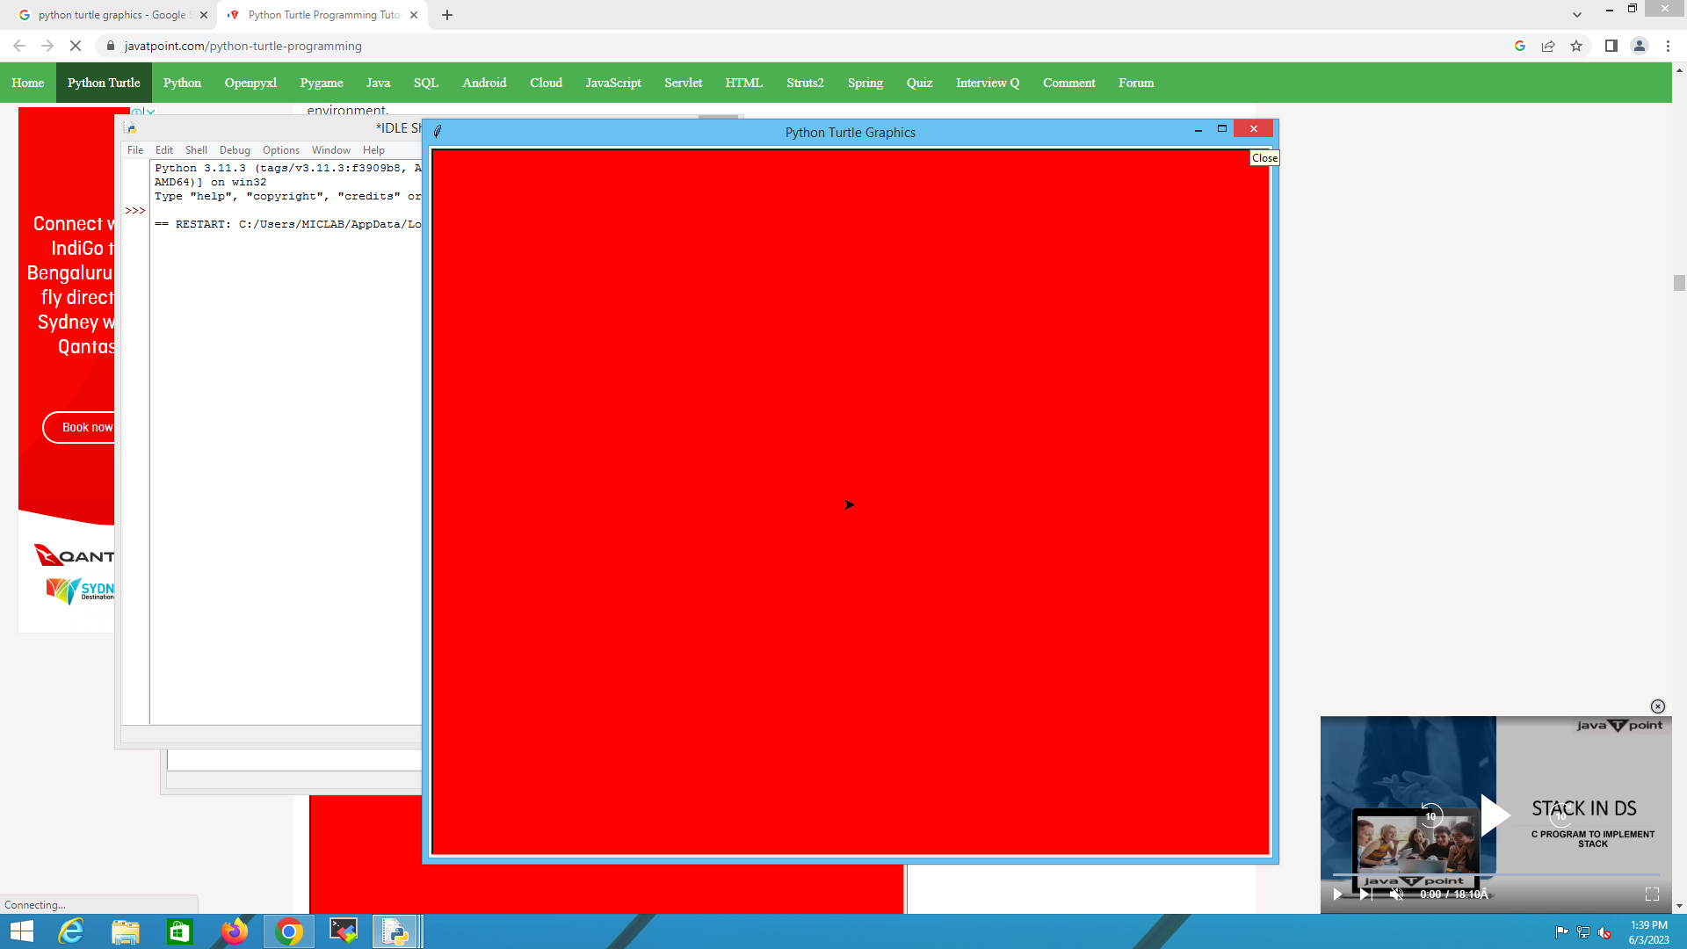

1. **Write a python program to print square shape using turtle graphics?**

import turtle

my_pen = turtle.Turtle()

for i in range(4):

my_pen.forward(50)

my_pen.right(90)

turtle.done()

**sample output:**

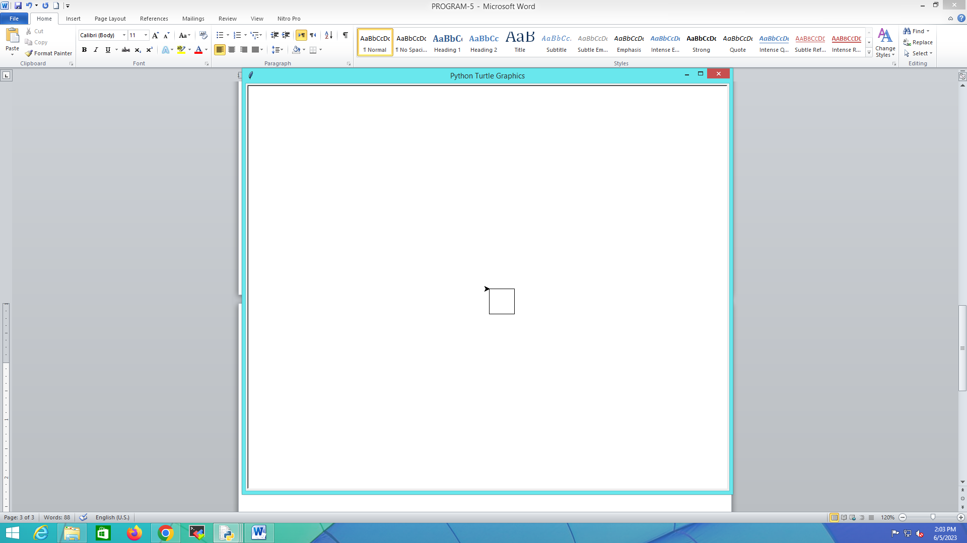

1. **Write a python program to print a star symbol using turtle graphics?**

import turtle

my_pen = turtle.Turtle()

for i in range(50):

my_pen.forward(50)

my_pen.right(144)

turtle.done()

**sample output:**

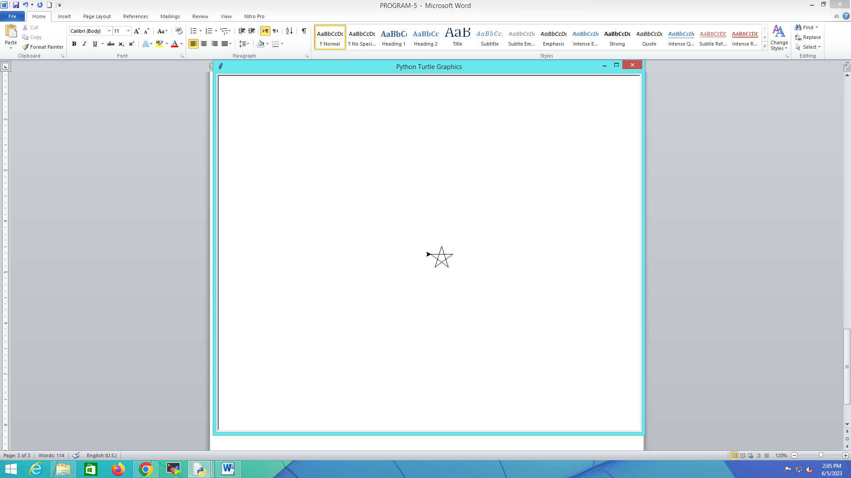

1. **Write a python program to print hexagon shape using turtle graphics?**

import turtle

polygon = turtle.Turtle()

my_num_sides = 6

my_side_length = 70

my_angle = 360.0 / my_num_sides

for i in range(my_num_sides):

polygon.forward(my_side_length)

polygon.right(my_angle)

turtle.done()

**sample output:**

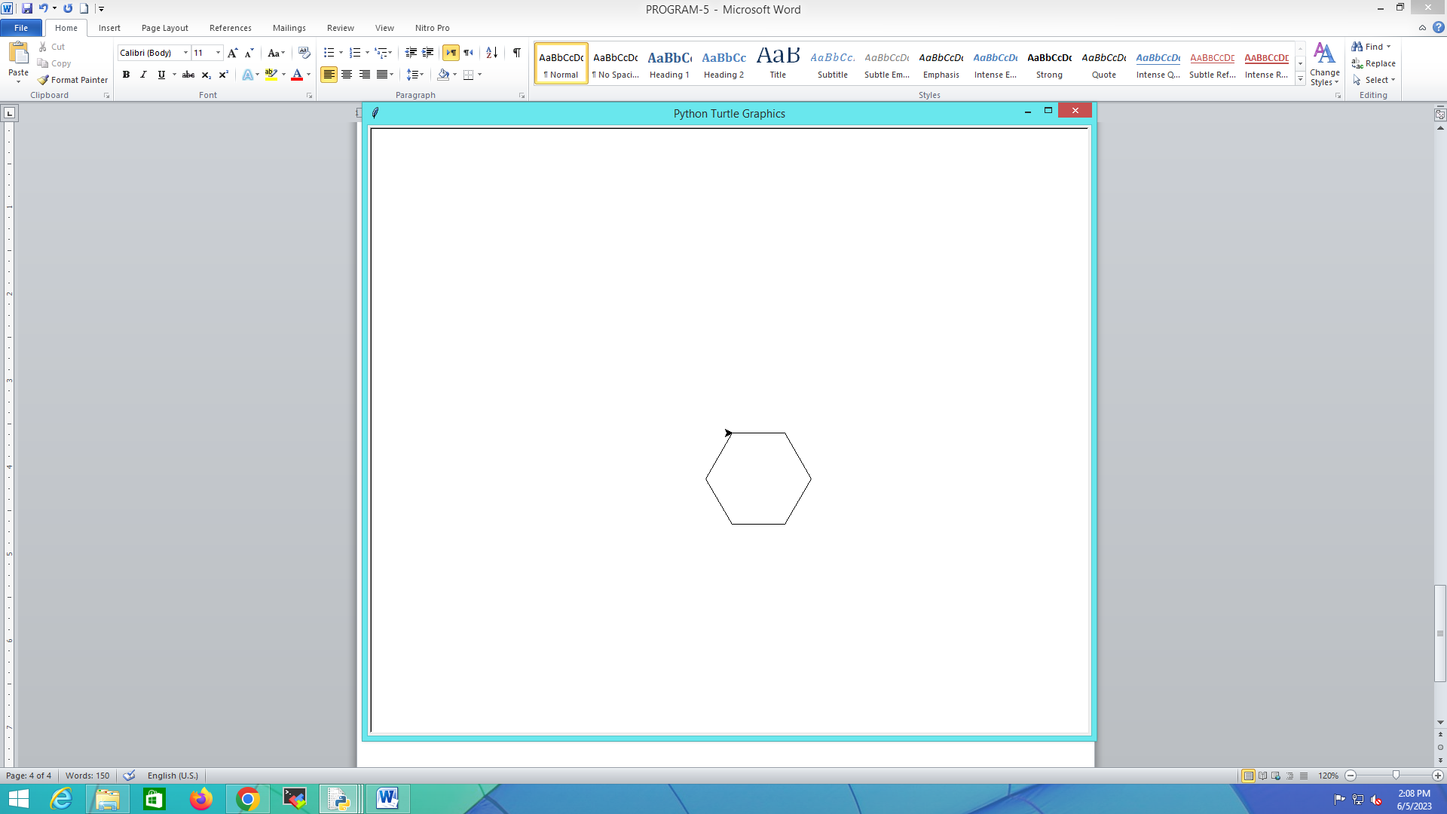

1. **Write a python program to print another pattern using turtle ?**

import turtle

colors = [ "red","purple","blue","green","orange","yellow"]

my_pen = turtle.Pen()

turtle.bgcolor("black")

for x in range(360):

my_pen.pencolor(colors[x % 6])

my_pen.width(x/100 + 1)

my_pen.forward(x)

my_pen.left(59)

**sample output:**

